**­­­­PROJECT REPORT**

A NOVEL METHOD FOR HANDWRITTEN DIGIT RECOGNITION

**submitted by**

**PNT2022TMID27424**

Nithya Kalyani M - 311019205032

Haritha Ravikumar - 311019205016

Shalini K - 311019205041

Saranya P - 311019205040

**TABLE OF CONTENTS**

1. INTRODUCTION 1
   1. 1.1 PROJECT OVERVIEW 1

1.2 PURPOSE 1

1. LITERATURE SURVEY 2

2.1 EXISTING PROBLEM 2

2.2 REFERENCES 2

2.3 PROBLEM STATEMENT DEFINITION 4

1. IDEATION AND PROPOSED SOLUTION 6

3.1 EMPATHY MAP CANVAS 5

3.2 IDEATION & BRAINSTORMING 6

3.3 PROPOSED SOLUTION 7

3.4 PROBLEM SOLUTION FIT 8

1. REQUIREMENT ANALYSIS 9

4.1 FUNCTIONAL REQUIREMENTS  9

4.2 NON-FUNCTIONAL REQUIREMENTS 10

1. PROJECT DESIGN 11

5.1 DATA FLOW DIAGRAM 11

* 1. SOLUTION & TECHNICAL ARCHITECTURE 13

5.3 COMPOMENTS AND TECHNOLOGIES 14

5.4 USER STORIES 15

1. PROJECT PLANNING AND SCHEDULING 16

6.1 SPRINT PLANNING AND ESTIMATION 16

6.2 SPRINT DELIVERY SCHEDULE 18

6.3 REPORT FROM JIRA 18

1. CODING & SOLUTIONING 19

7.1 FEATURE 1 19

7.2 FEATURE 2 20

7.3 FEATURE 3 20

1. TESTING 21

8.1 TEST CASES 21

8.2 USER ACCEPTANCE TESTING 23

8.2.1 DEFECT ANALYSIS 23

8.2.2 TEST CASE ANALYSIS 23

1. RESULTS 24

9.1 PERFORMANCE METRICS 24

1. ADVANTAGES & DISADVANTAGES 26

ADVANTAGES 26

DISADVANTAGES 26

1. CONCLUSION 27
2. FUTURE SCOPE 28

APPENDIX 29

SOURCE CODE 29

GITHUB 39

# CHAPTER 1

## INTRODUCTION

### 1.1 PROJECT OVERVIEW

Handwritten Digit Recognition is the capacity of a computer to interpret the manually written digits from various sources like messages, bank cheques, papers, pictures, and so forth and in various situations for web-based handwriting recognition on PC tablets, identifying number plates of vehicles, handling bank cheques, digits entered in any forms etc. Machine Learning provides various methods through which human efforts can be reduced in recognizing the manually written digits.

Deep Learning is a machine learning method that trains computers to do what easily falls into place for people: learning through examples. With the utilization of deep learning methods, human attempts can be diminished in perceiving, learning, recognizing and in a lot more regions. Using deep learning, the computer learns to carry out classification works from pictures or contents from any document. Deep Learning models can accomplish state-of-art accuracy, beyond the human level performance. The digit recognition model uses large datasets in order to recognize digits from distinctive sources.

### PURPOSE

### The main objective was to actualize a pattern characterization method to perceive the handwritten digits provided in the MINIST data set of images of handwritten digits (0‐9). The goal of our work is to create a model that will be able to recognize and classify the handwritten digits from images by using concepts of Convolution Neural Network. Though the goal of our research is to create a model for digit recognition and classification, it can also be extended to letters and an individual’s handwriting. With high accuracy rates, the model can solve a lot of real life problems.

### The main applications are vehicle license-plate recognition, postal letter-sorting services, Cheque truncation system (CTS) scanning and historical document preservation in archaeology departments, old documents automation in libraries and banks, etc. All these areas deal with large databases and hence demand high recognition accuracy, lesser computational complexity and consistent performance of the recognition system.

# CHAPTER 2

## LITERATURE SURVEY

### 2.1 EXISTING PROBLEM

The fundamental problem with handwritten digit recognition is that handwritten digits do not always have the same size, width, orientation, and margins since they vary from person to person. People can struggle to read others’ handwriting. The handwritten digits are not always of the same size, width, orientation as they differ from writing of person to person, so the general problem would be while classifying the digits.

Additionally, there would be issues with identifying the numbers because of similarities between numerals like 1 and 7, 5 and 6, 3 and 8, 2 and 5, 2 and 7, etc. Finally, the individuality and variation of each individual's handwriting inﬂuence the structure and appearance of the digits.

### REFERENCES

**Handwritten Digit Recognition using CNN (2019)**

*Vijayalaxmi R Rudraswamimath 1, Bhavanishankar K2*

Digit Recognition is a noteworthy and important issue. As the manually written digits are not of a similar size, thickness, position and direction, in this manner, various difficulties must be considered to determine the issue of handwritten digit recognition. The uniqueness and assortment in the composition styles of various individuals additionally influence the example and presence of the digits. It is the strategy for perceiving and arranging transcribed digits. It has a wide range of applications, for example, programmed bank checks, postal locations and tax documents and so on. The aim of this project is to implement a classification algorithm to recognize the handwritten digits. The after effects of probably the most broadly utilized Machine Learning Algorithms like SVM, KNN and RFC and with Deep Learning calculation like multilayer CNN utilizing Keras with Theano and Tensorflow. Utilizing these, the accuracy of 98.70% utilizing CNN (Keras + Theano) when contrasted with 97.91% utilizing SVM, 96.67% utilizing KNN, 96.89% utilizing RFC was obtained.

**Handwritten Digit Recognition Using Machine And Deep Learning Algorithms (2021)**

*Pashine, Samay and Dixit, Ritik and Kushwah, Rishika*

In this study, they developed three deep and machine learning-based models for handwritten digit recognition using MNIST datasets. In their research, they discovered that CNN produced the most precise outcomes for handwritten digit recognition. This led them to the conclusion that CNN is the most effective 5 solution for all types of prediction issues, including those using picture data. Next, by comparing the execution times of the algorithms, they determined that increasing the number of epochs without changing the configuration of the algorithm is pointless due to the limitation of a certain model, and they discovered that beyond a certain number of epochs, the model begins over-fitting the dataset and provides biased predictions.

**An Efficient And Improved Scheme For Handwritten Digit Recognition Based On Convolutional Neural Network (2019)**

*Ali, Saqib and Shaukat, Zeeshan and Azeem, Muhammad and Sakhawat, Zareen and Mahmood, Tariq and others*

This study uses rectified linear units (ReLU) activation and a convolutional neural network (CNN) that incorporates the Deeplearning4j (DL4J) architecture to recognize handwritten digits. The proposed CNN framework has all the necessary parameters for a high level of MNIST digit classification accuracy. The system's training takes into account the time factor as well. The system is also tested by altering the number of CNN layers for additional accuracy verification. It is important to note that the CNN architecture consists of two convolutional layers, the first with 32 filters and a 5x5 window size and the second with 64 filters and a 7x7 window size. In comparison to earlier proposed systems, the experimental findings show that the proposed CNN architecture for the MNIST dataset demonstrates great performance in terms of time and accuracy. As a result, handwritten numbers are detected with a recognition rate of 99.89% and high precision (99.21%) in a short amount of time.

**Improved Handwritten Digit Recognition Using Convolutional Neural Networks (CNN) (2020)**

*Ahlawat, Savita and Choudhary, Amit and Nayyar, Anand and Singh, Saurabh and Yoon, Byungun*

This paper's primary goal was to enhance handwritten digit recognition ability. To avoid difficult pre-processing, expensive feature extraction, and a complex ensemble (classifier combination) method of a standard recognition system, they examined different convolutional neural network variations. Their current work makes suggestions on the function of several hyper-parameters through thorough evaluation utilizing an MNIST dataset. They also confirmed that optimizing hyper-parameters is crucial for enhancing CNN architecture performance. With the Adam optimizer for the MNIST database, they were able to surpass many previously published results with a recognition rate of 99.89%. Through the trials, it is made 3 abundantly evident how the performance of handwritten digit recognition is affected by the number of convolutional layers in CNN architecture. According to the paper, evolutionary algorithms can be explored for optimizing convolutional filter kernel sizes, CNN learning parameters, and the quantity of layers and learning rates.

**A novel method for Handwritten Digit Recognition with Neural Networks(2020)**

*Malothu Nagu*1, N Vijay Shankar#2, K.Annapurna*

Character recognition plays an important role in the modern world. It can solve more complex problems and makes humans’ job easier. An example is handwritten character recognition. This is a system widely used in the world to recognize zip code or postal code for mail sorting. There are different techniques that can be used to recognize handwritten characters. Two techniques researched in this paper are Pattern Recognition and Artificial Neural Network (ANN). Both techniques are defined and different methods for each technique is also discussed. Bayesian Decision theory, Nearest Neighbor rule, and Linear Classification or Discrimination is types of methods for Pattern Recognition. Shape recognition, Chinese Character and Handwritten Digit recognition uses Neural Network to recognize them. Neural Network is used to train and identify written digits. After training and testing, the accuracy rate reached 99%. This accuracy rate is very high.

### PROBLEM STATEMENT DEFINITION

The problem statement is to classify handwritten digits. The goal is to take an image of a handwritten digit and determine what that digit and character is. It is easy for the human to perform a task accurately by practicing it repeatedly and memorizing it for the next time. Human brain can process and analyze images easily. Also, recognize the different elements present in the images.

The handwritten digit recognition is the capability of computer applications to recognize the human handwritten digits. It is a hard task for the machine because handwritten digits are not perfect and can be made with many different shapes and sizes. The handwritten digit recognition system is a way to tackle this problem which uses the image of a digit and recognizes the digit present in the image. Convolutional Neural Network model created using Python library over the MNIST dataset to recognize handwritten digits. Handwriting number recognition is a challenging problem researchers had been research into this area for so long especially in the recent years.

# CHAPTER 3

## IDEATION AND PROPOSED SOLUTION

**­­­­**

### 3.1 EMPATHY MAP CANVAS

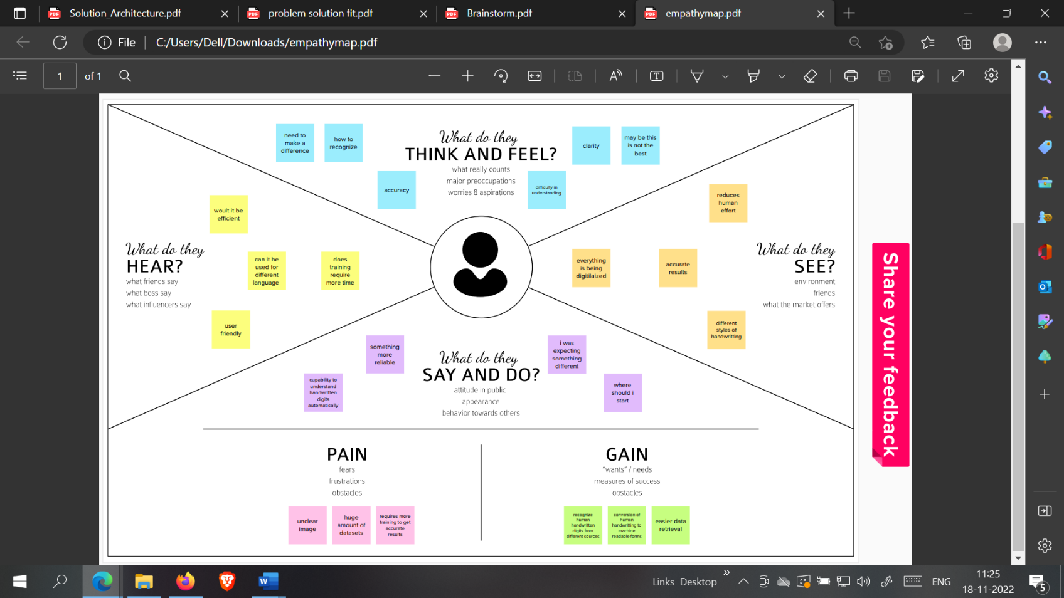­­­­

### IDEATION & BRAINSTORMING

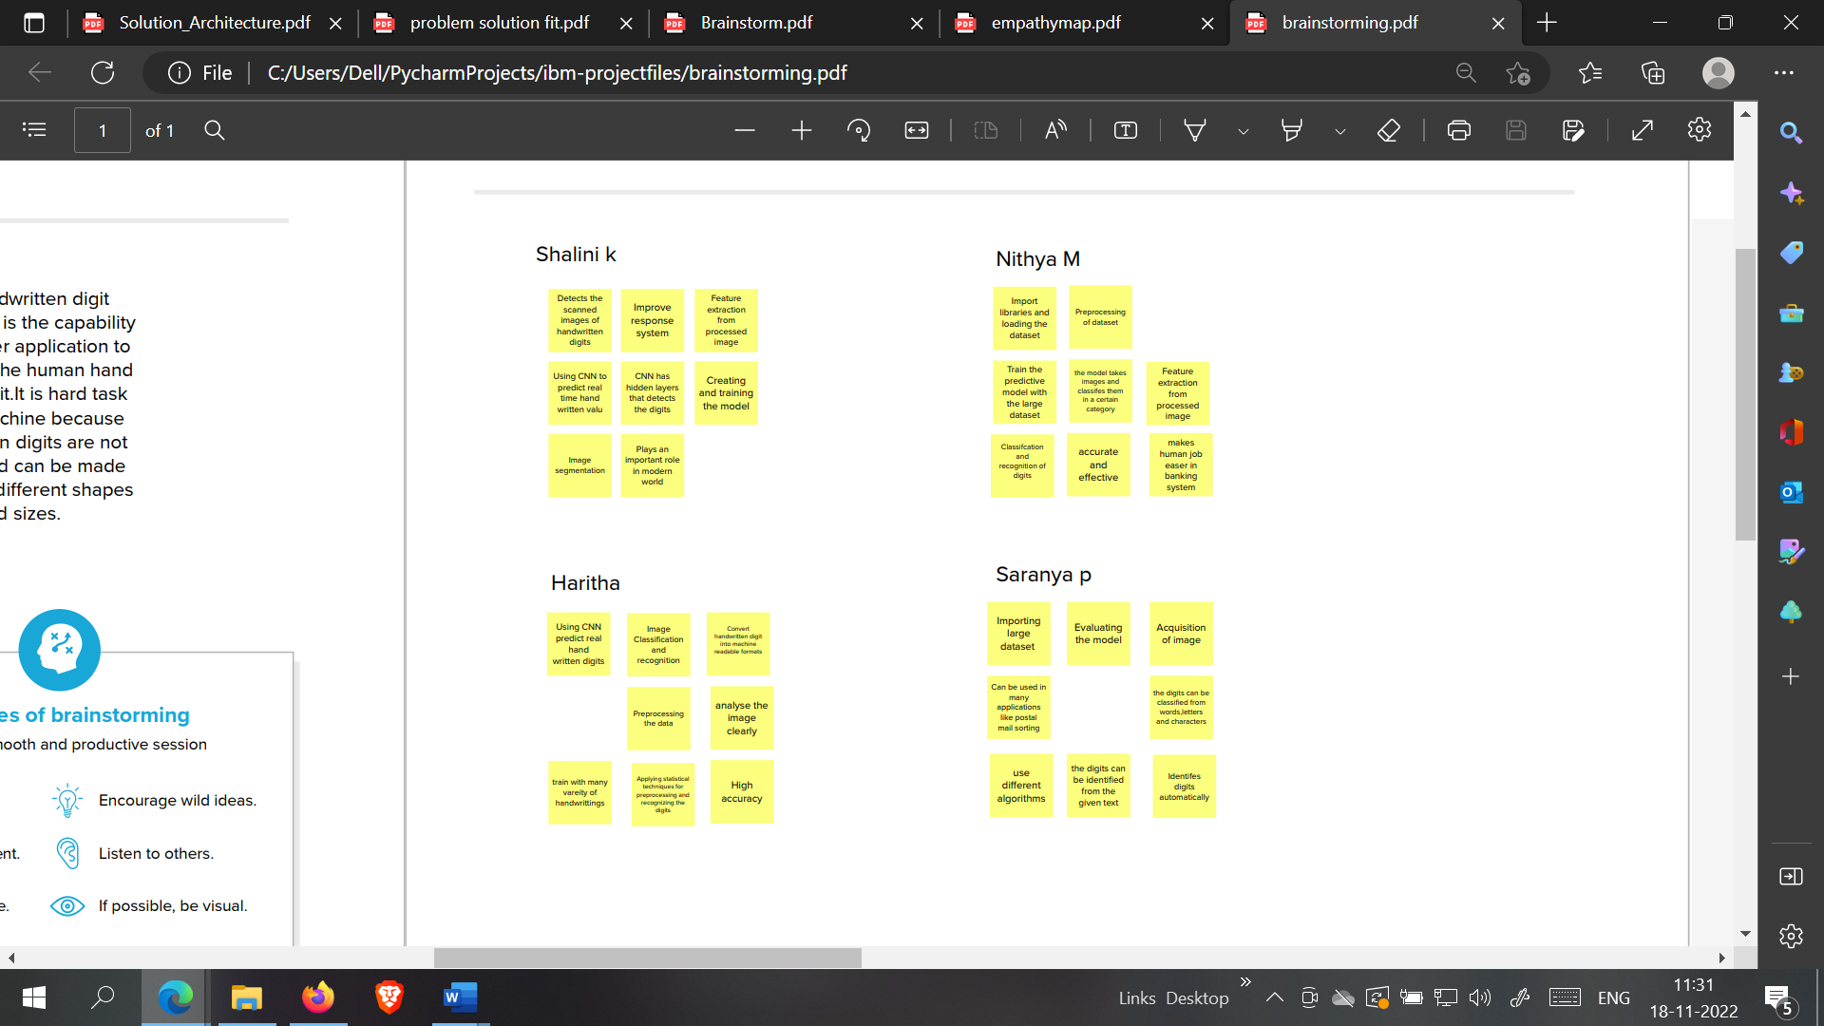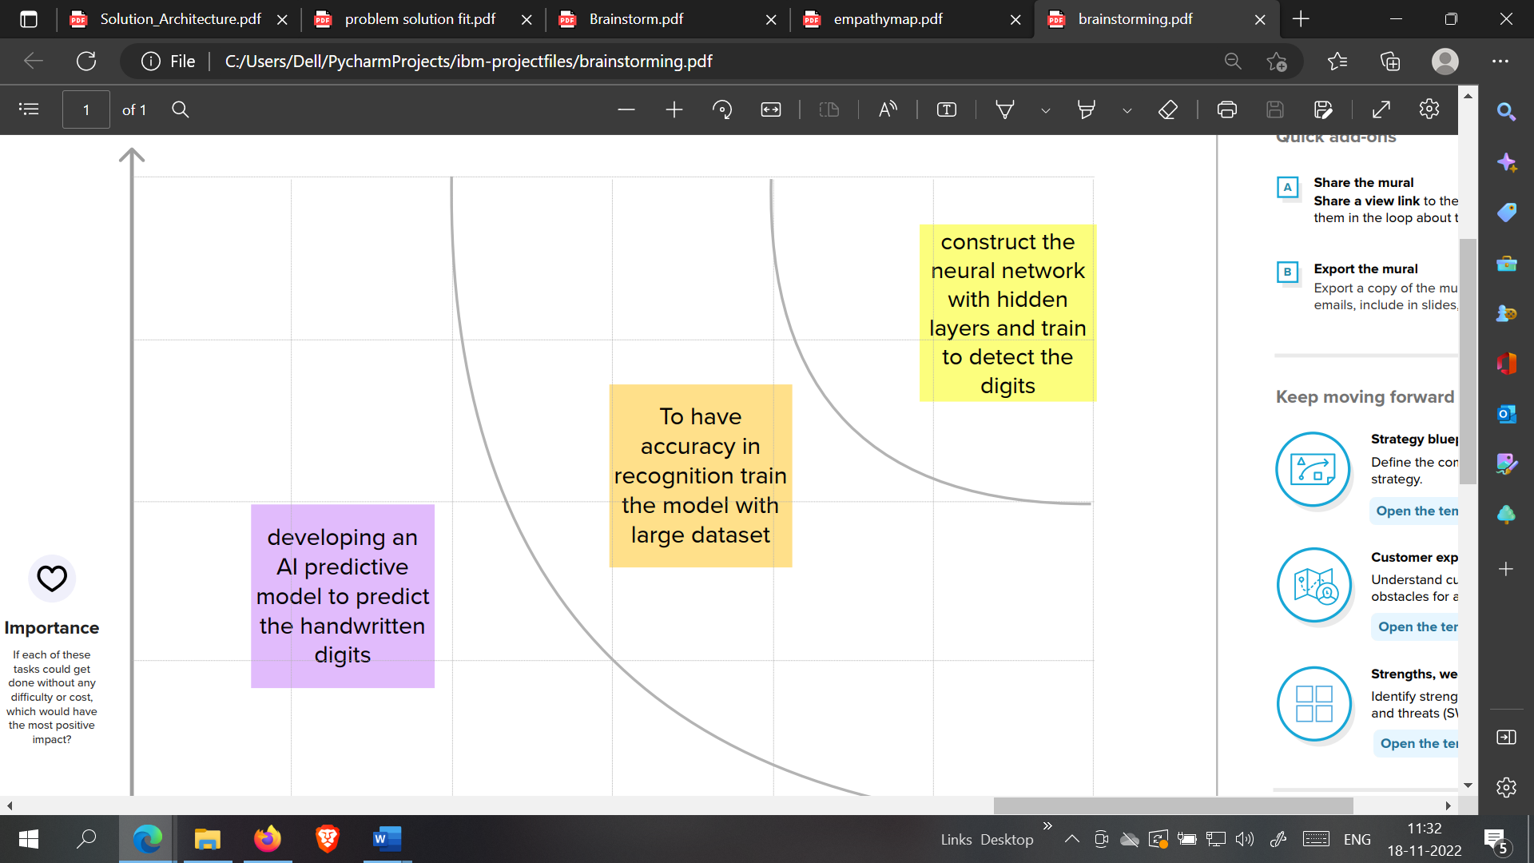

### PROPOSED SOLUTION

|  |  |  |
| --- | --- | --- |
| **S.No.** | **Parameter** | **Description** |
|  | Problem Statement (Problem to be solved) | The problem statement aims at developing a novel handwritten recognition system using ML. The handwritten digit recognition system is a way to tackle the problem which uses the image of a digit and recognizes the digit present in the image . |
|  | Idea / Solution description | Developing an AI predictive model to predict the handwritten digits and to construct a neural network with hidden layers and train to detect the digits. |
|  | Novelty / Uniqueness | The system not only produces a classification of the digit but also a rich description of the instantiation parameters which can yield information such as the writing style. |
|  | Social Impact / Customer Satisfaction | Handwritten digits can be recognized easily without any strenuous efforts. This reduces time and improves productivity for people. |
|  | Business Model (Revenue Model) | It is used in thedetection of vehicle numbers, banks for reading cheques, post offices for arranging letters, and many other tasks. |
|  | Scalability of the Solution | To attain higher performances in the domain of character recognition and pattern recognition, due to its excellent feature extraction and working as best classifier characteristics. There is no limit in the number of digits that can be recognized. |

### PROBLEM SOLUTION FIT

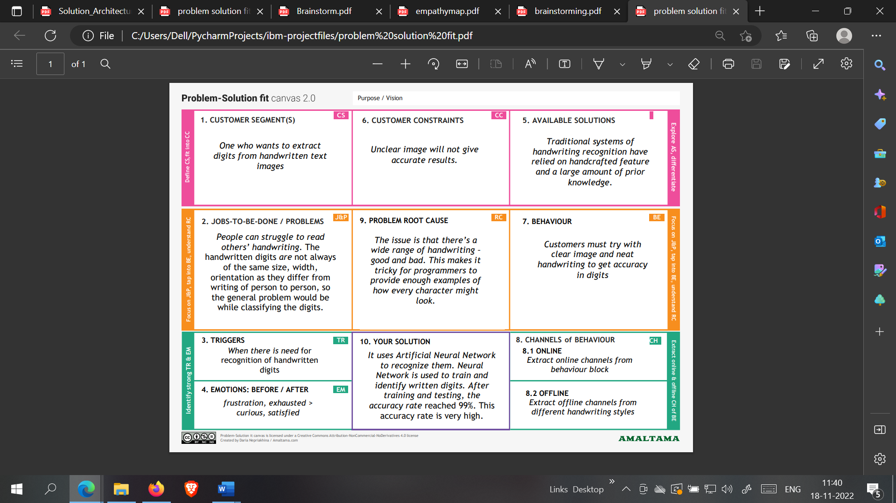

# CHAPTER 4

## REQUIREMENT ANALYSIS

### FUNCTIONAL REQUIREMENTS

|  |  |  |
| --- | --- | --- |
| **FR No.** | **Functional Requirement (Epic)** | **Sub Requirement (Story / Sub-Task)** |
| FR-1 | User Registration | Registration through Form  Registration through Gmail  Registration through LinkedIn |
| FR-2 | User Confirmation | Confirmation via Email  Confirmation via OTP |
| FR-3 | Upload image | Image upload via files  Image upload via folders  Image upload via drive  Image upload via web  Image upload via scan/camera |
| FR-4 | Spelling support | Identifies handwriting of different styles and fonts  Spelling check |
| FR-5 | Translation | Handwritten digits from the image are extracted.  Conversion of handwritten digits into machine readable form |
| FR-6 | Log out | Log out / sign out. |

### 

### 4.2 NON-FUNCTIONAL REQUIREMENTS

|  |  |  |
| --- | --- | --- |
| **FR No.** | **Non-Functional Requirement** | **Description** |
| NFR-1 | **Usability** | The proposed system gives good results for images that contain handwritten text written in different styles, different size and alignment with varying background |
| NFR-2 | **Security** | Only authorized people can access the system data and modify the database. |
| NFR-3 | **Reliability** | The Database is frequently updated with handwriting of different styles and size and will rollback when any update fails. |
| NFR-4 | **Performance** | The proposed system is advantageous as it uses  fewer features to train the neural network, which results in faster convergence. |
| NFR-5 | **Availability** | The system functionality and services are available for use with all operations. |
| NFR-6 | **Scalability** | The website traffic limit must be scalable enough to support 2 lakhs users at a time |

# CHAPTER 5

## PROJECT DESIGN

### 5.1 DATA FLOW DIAGRAM

A Data Flow Diagram (DFD) is a traditional visual representation of the information flows within a system. A neat and clear DFD can depict the right amount of the system requirement graphically. It shows how data enters and leaves the system, what changes the information, and where data is stored.

**DFD Level-0**

The DFD Level-0 consists of two external entities, the UI and the Output, along with a process, representing the CNN for Digit Recognition .Output is obtained after processing.

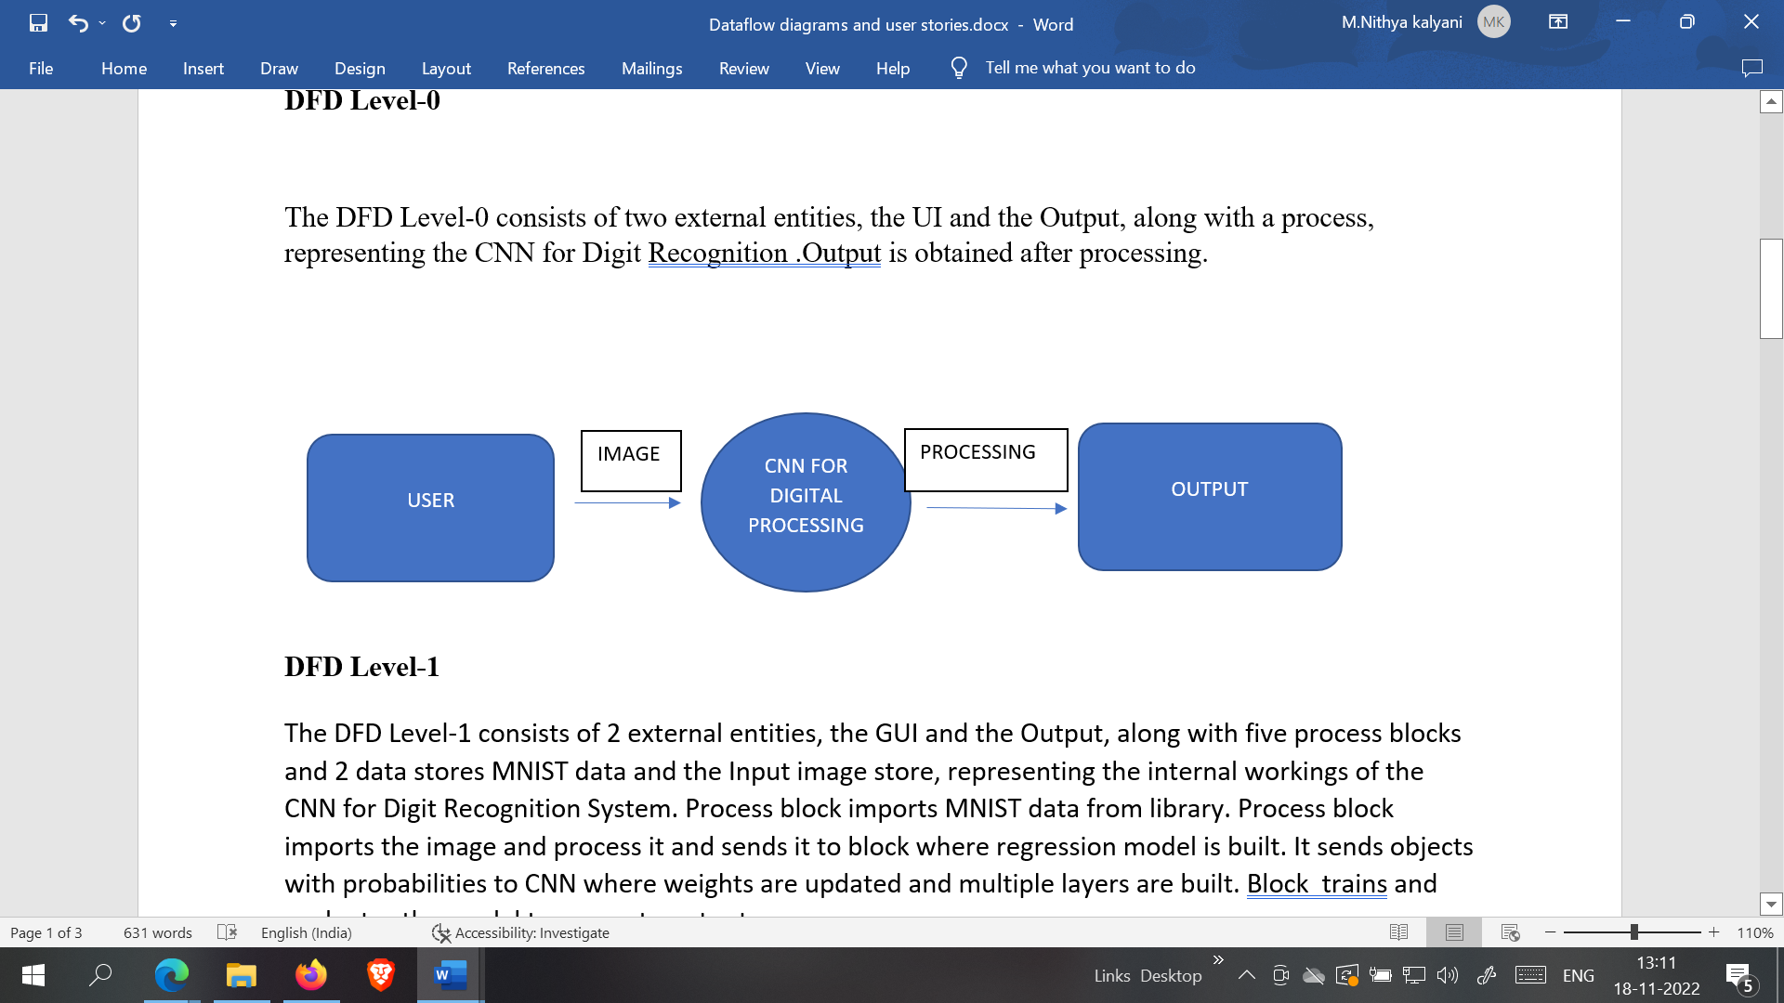

**DFD Level-1**

The DFD Level-1 consists of 2 external entities, the GUI and the Output, along with five process blocks and 2 data stores MNIST data and the Input image store, representing the internal workings of the CNN for Digit Recognition System. Process block imports MNIST data from library. Process block imports the image and process it and sends it to block where regression model is built. It sends objects with probabilities to CNN where weights are updated and multiple layers are built. Block trains and evaluates the model to generate output.

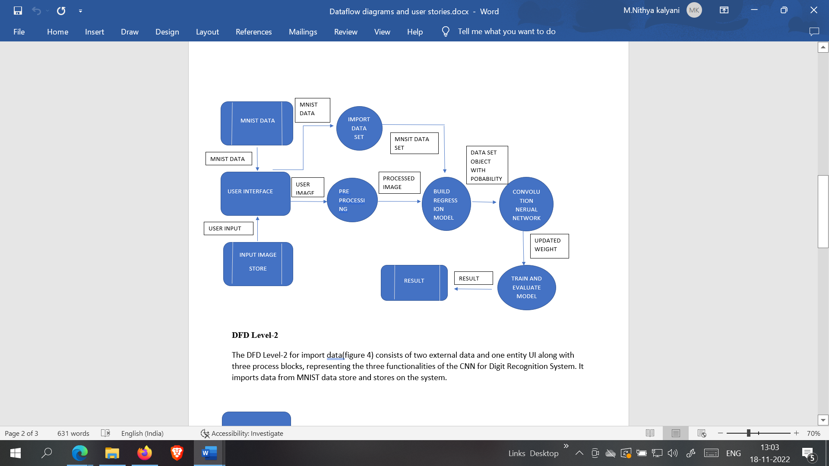

**DFD Level-2**

The DFD Level-2 for import data(figure 4) consists of two external data and one entity UI along with three process blocks, representing the three functionalities of the CNN for Digit Recognition System. It imports data from MNIST data store and stores on the system.

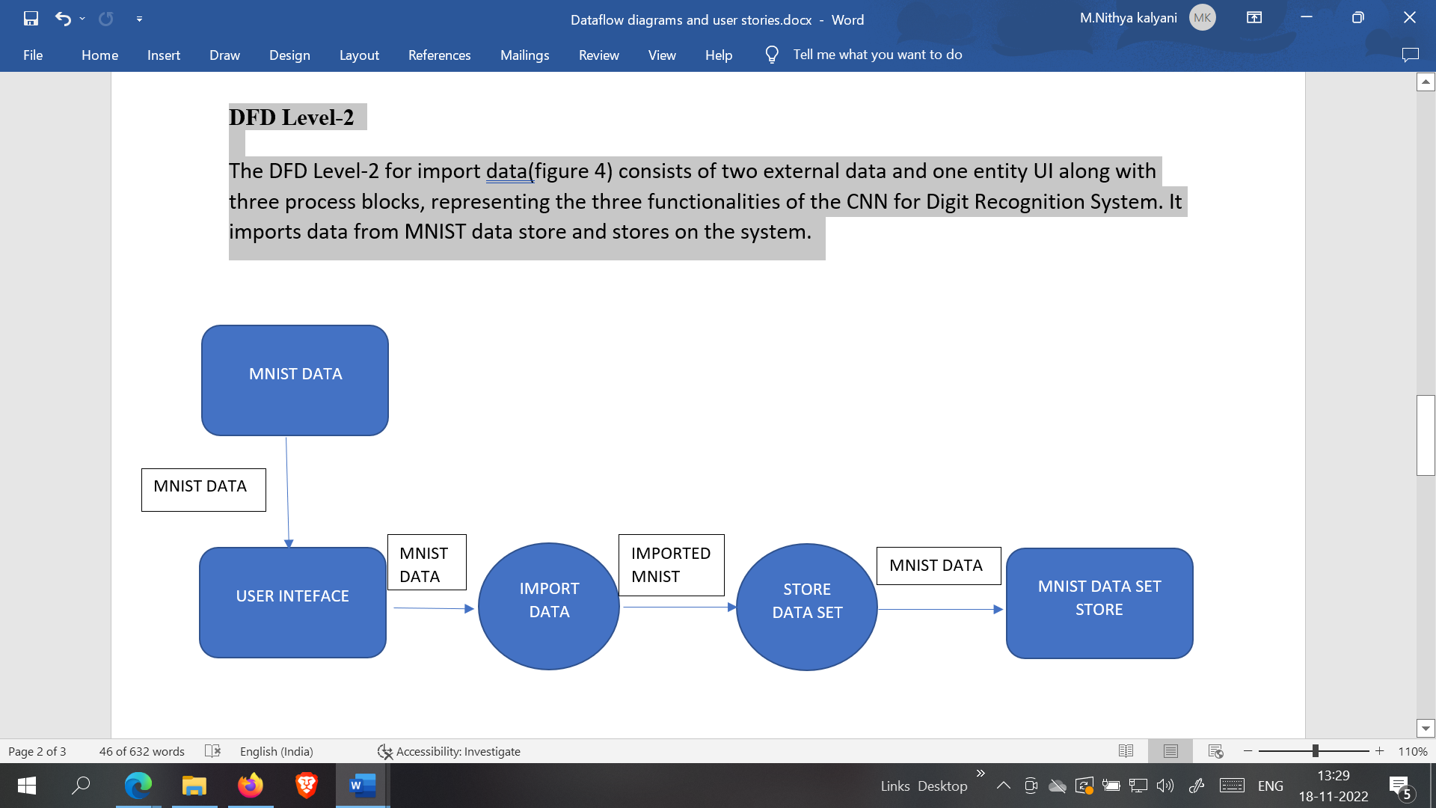

### 5.2 SOLUTION & TECHNICAL ARCHITECTURE

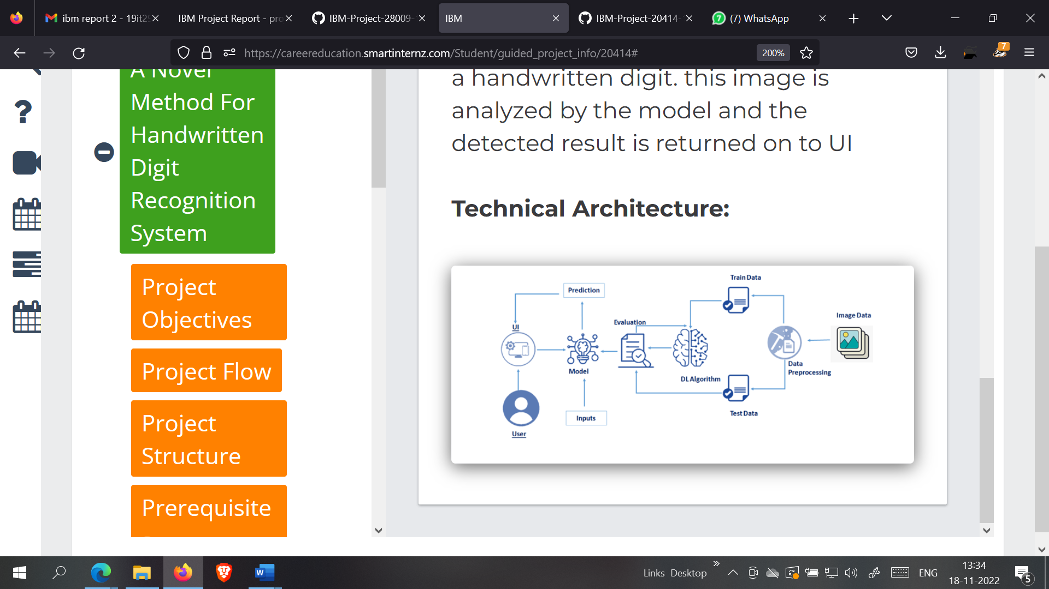

**MNIST DATASET PROCESSING WITH PYTHON**

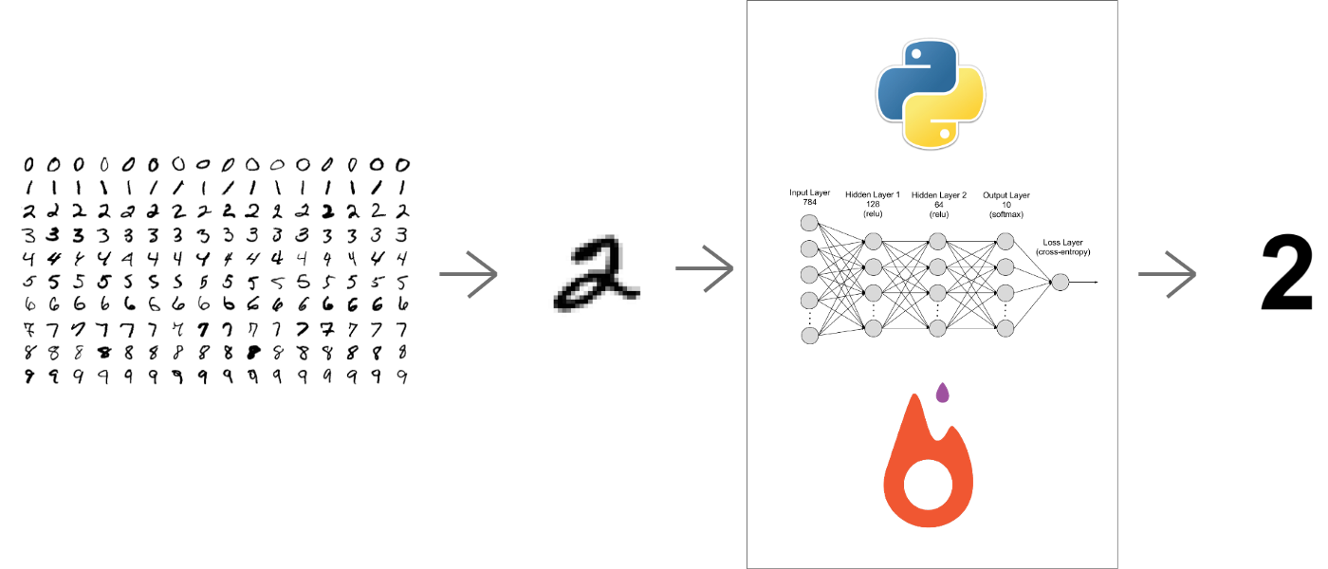

### 

### 

**5.3 COMPONENTS & TECHNOLOGIES:**

|  |  |  |  |
| --- | --- | --- | --- |
| **S.No** | **Component** | **Description** | **Technology** |
|  |  |  |  |
| 1. | User Interface | How user interacts with application e.g., Mobile Application | HTML, CSS, JavaScript |
|  |  |  |  |
| 2. | Application Logic-1 | Logic for a process in the application | Java / Python |
|  |  |  |  |
| 3. | Application Logic-2 | Logic for a process in the application | IBM Watson STT service |
|  |  |  |  |
| 4. | Application Logic-3 | Logic for a process in the application | IBM Watson Assistant |
|  |  |  |  |
| 5. | Database | Data Type, Configurations etc. | MySQL, NoSQL, etc. |
|  |  |  |  |
| 6. | Cloud Database | Database Service on AI in cloud | IBM DB2 |
|  |  |  |  |
| 7. | File Storage | File storage requirements | IBM Block Storage or Other Storage Service or local file system |
|  |  |  |  |
| 8. | External API-1 | Purpose of External API used in the application | IBM Weather API, etc. |
|  |  |  |  |
| 9. | Internet of Things Model | Purpose of AI Model is for integrating the sensors with a user interface | IBM AI Platform |
|  |  |  |  |
| 10. | Machine Learning Model | Purpose of Machine Learning Model | Digit Recognition Model |
|  |  |  |  |

### USER STORIES

|  |  |  |  |  |  |  |
| --- | --- | --- | --- | --- | --- | --- |
| User Type | Functional Requirement | User Story Number | User Story / Task | Acceptance Criteria | Priority | Release |
| Customer | Building  the application | USN-1 | As a user, I should be able to access the application from anywhere and use on any devices | User can access the application using the browser on any device | High | Sprint-4 |
| Uploading Image | USN-2 | As a user, I should be able to upload images to predict the digits | User can upload images | High | Sprint-2 |
| Viewing the Results | USN-3 | As a user, I should be able to view the results | The result of the prediction is displayed | High | Sprint-3 |
| Viewing Other Prediction | USN-4 | As a user, I should be able to see other close predictions | The accuracy of other values must be displayed | Medium | Sprint-1 |
| Usage Instruction | USN-5 | As a user, I should have a usage instruction to know how to use the application | The usage instruction is displayed on the home page | Medium | Sprint-3 |

# CHAPTER 6

## PROJECT PLANNING AND SCHEDULING

### 6.1 SPRINT PLANNING AND ESTIMATION

| **Sprint** | **Functional Requirement (Epic)** | **User Story Number** | **User Story / Task** | **Story Points** | **Priority** | **Team Members** |
| --- | --- | --- | --- | --- | --- | --- |
| Sprint-1 | Data Collection | USN-1 | As a user, I can collect the dataset from various resources with different handwritings. | 10 | Low | Saranya P  Shalini K |
| Sprint-1 | Data Pre-processing | USN-2 | As a user, I can load the dataset, handling the missing data, scaling and split data into train and test. | 10 | Medium | Saranya P  Shalini K |
| Sprint-2 | Model Building | USN-3 | As a user, I will get an application with ML model which provides high accuracy of recognized handwritten digit. | 5 | High | M.Nithya Kalyani  Haritha Ravikumar Shalini K |
| Sprint-2 | Add CNN layers | USN-4 | Creating the model and adding the input, hidden, and output layers to it. | 5 | High | M.Nithya Kalyani  Haritha Ravikumar Shalini k |
| Sprint-2 | Compiling the model | USN-5 | With both the training data defined and model defined, it's time to configure the learning process. | 2 | Medium | M.Nithya Kalyani  Haritha Ravikumar |
| Sprint-2 | Train & test the model | USN-6 | As a user, let us train our model with our image dataset. | 6 | Medium | M.Nithya Kalyani  Haritha Ravikumar |
| Sprint-2 | Save the model | USN-7 | As a user, the model is saved & integrated with an android application or web application in order to predict something. | 2 | Low | Haritha Ravikumar |
| Sprint-3 | Building UI Application | USN-8 | As a user, I will upload the handwritten digit image to the application by clicking a upload button. | 5 | High | M.Nithya Kalyani  Shalini K |
| Sprint-3 |  | USN-9 | As a user, I can know the details of the fundamental usage of the application. | 5 | Low | Shalini K |
| Sprint-3 |  | USN-10 | As a user, I can see the predicted / recognized digits in the application. | 5 | Medium | Saranya P  Shalini K |
| Sprint-4 | Train the model on IBM | USN-11 | As a user, I train the model on IBM and integrate flask/Django with scoring end point. | 10 | High | Shalini K  M.Nithya Kalyani  Haritha Ravikumar |
| Sprint-4 | Cloud Deployment | USN-12 | As a user, I can access the web application and make the use of the product from anywhere. | 10 | High | Saranya P  Shalini K |

### 6.2 SPRINT DELIVERY SCHEDULE

| **Sprint** | **Total Story Points** | **Duration** | **Sprint Start Date** | **Sprint End Date (Planned)** | **Story Points**  **Completed (as on Planned End Date)** | **Sprint Release Date (Actual)** |
| --- | --- | --- | --- | --- | --- | --- |
| Sprint-1 | 20 | 6 Days | 24 Oct 2022 | 29 Oct 2022 | 20 | 29 Oct 2022 |
| Sprint-2 | 20 | 6 Days | 31 Oct 2022 | 05 Nov 2022 | 20 | 05 Nov 2022 |
| Sprint-3 | 20 | 6 Days | 07 Nov 2022 | 12 Nov 2022 | 20 | 12 Nov 2022 |
| Sprint-4 | 20 | 6 Days | 14 Nov 2022 | 19 Nov 2022 | 20 | 19 Nov 2022 |

**6.3 REPORT FROM JIRA**

**Velocity:**

Imagine we have a 10-day sprint duration, and the velocity of the team is 20 (points per sprint). Let’s calculate the team’s average velocity (AV) per iteration unit (story points per day)

Average Velocity = 20 / 6 = 3.33

**Burndown Chart:**

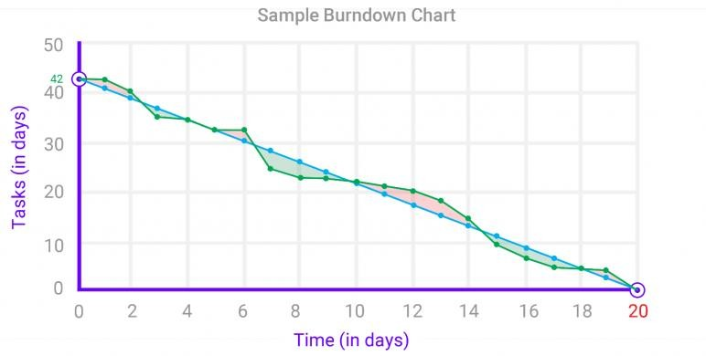A burn down chart is a graphical representation of work left to do versus time. It is often used in agile[software development](https://www.visual-paradigm.com/scrum/what-is-agile-software-development/) methodologies such as [Scrum](https://www.visual-paradigm.com/scrum/scrum-in-3-minutes/). However, burn down charts can be applied to any project containing measurable progress over time.

**CHAPTER 7**

**CODING & SOLUTION**

**7.1 FEATURE 1 – FLASK FILE UPLOADING**

Handling file upload in Flask is very easy. It needs an HTML form with its enctype attribute set to ‘multipart/form-data’, posting the file to a URL. The URL handler fetches file from request.files[] object and saves it to the upload folder.

import numpy as np  
import os  
from PIL import Image  
from flask import Flask, request, render_template  
from werkzeug.utils import secure_filename  
from keras.models import load_model  
  
UPLOAD_FOLDER = 'C:/Users/Dell/PycharmProjects/A-novel-method-for-digit-recognition-system/flask_app/uploads'  
  
app = Flask(__name__)  
app.config['UPLOAD_FOLDER'] = UPLOAD_FOLDER  
  
model = load_model("mnistCNN.h5")  
  
@app.route('/')  
def index():  
 return render_template('index.html')  
  
@app.route('/predict', methods=['GET', 'POST'])  
def upload():  
 if request.method == "POST":  
 f = request.files["image"]  
 filepath = secure_filename(f.filename)  
 f.save(os.path.join(app.config['UPLOAD_FOLDER'], filepath))  
  
 upload_img = os.path.join(UPLOAD_FOLDER, filepath)  
 img = Image.open(upload_img).convert("L") # convert image to monochrome  
 img = img.resize((28, 28)) # resizing of input image  
  
 im2arr = np.array(img) # converting to image  
 im2arr = im2arr.reshape(1, 28, 28, 1) # reshaping according to our requirement  
  
 pred = model.predict(im2arr)  
 num = np.argmax(pred, axis=1) # printing our Labels  
  
 return render_template('predict.html', num=str(num[0]))  
  
if __name__ == '__main__':  
 app.run(debug=True, threaded=False)

**7.2 FEATURE 2 – UPLOAD IMAGE WITH PREVIEW**

A preview refers to a feature that lets you glimpse or view something in part or whole without it being opened. A picture preview would show a small version of the picture and give you a good idea what each picture is without opening each picture it is a useful feature created using JavaScript.

<section id="content">  
  
 <div class="leftside">  
 <form action="/predict" method="POST" enctype="multipart/form-data">  
 <label>Select a image:</label>  
 <input id="image" type="file" name="image" accept="image/png, image/jpeg" onchange="preview()"><br><br>  
 <img id="frame" src="" width="100px" height="100px"/>  
 <div class="buttons_div">  
 <button type="submit" class="btn btn-dark" id="predict_button">Predict</button>  
 <button type="button" class="btn btn-dark" id="clear_button">&nbsp Clear &nbsp</button>  
 </div>  
 </form>  
 </div>  
</section>

function preview() {  
 frame.src=URL.createObjectURL(event.target.files[0]);  
}

**7.3 FEATURE 3 – CLEAR IMAGE**

This feature can be used to clear the image if we uploaded a wrong image or if we need to change the image. The clear button clears both the image value and the preview of the image in script tag.

<script>

$(document).ready(function() {  
 $('#clear_button').on('click', function() {  
 $('#image').val('');  
 $('#frame').attr('src',"");  
 });  
 });  
  
</scrip>

# CHAPTER 8

## TESTING

### 8.1 TEST CASES

|  |  |  |  |  |  |  |
| --- | --- | --- | --- | --- | --- | --- |
| **Test case ID** | **Feature Type** | **Component** | **Test Scenario** | **Expected Result** | **Actual Result** | **Status** |
| HP_TC_001 | UI | Home Page | Verify UI elements in the Home Page | The Home page must be displayed properly | Working as expected | FAIL |
| HP_TC_002 | UI | Home Page | Check if the UI elements are displayed properly in different screen sizes | The Home page must be displayed properly in all sizes | The UI is not displayed properly in screen size 2560 x 1801  and 768 x 630 | FAIL |
| HP_TC_003 | Functional | Home Page | Check if user can upload their ﬁle | The input image should be uploaded to the application successfully | Working as expected | PASS |
| HP_TC_004 | Functional | Home Page | Check if user cannot upload unsupported ﬁles | The application should not allow user to select a non image ﬁle | User is able to upload any ﬁle | FAIL |
| HP_TC_005 | Functional | Home Page | Check if the page redirects to the result page once the input is given | The page should redirect to the results page | Working as expected | PASS |

|  |  |  |  |  |  |  |
| --- | --- | --- | --- | --- | --- | --- |
| BE_TC_001 | Functional | Backend | Check if all the routes are working properly | All the routes should properly work | Working as expected | PASS |
| M_TC_001 | Functional | Model | Check if the model can handle various image sizes | The model should rescale the image and predict the results | Working as expected | PASS |
| M_TC_002 | Functional | Model | Check if the model predicts the digit | The model should predict the number | Working as expected | PASS |
| M_TC_003 | Functional | Model | Check if the model can handle complex input image | The model should predict the number in the complex image | The model fails to identify the digit since the model is not built to handle such data | FAIL |
| RP_TC_001 | UI | Result Page | Verify UI elements in the Result Page | The Result page must be displayed properly | Working as expected | PASS |
| RP_TC_002 | UI | Result Page | Check if the input image is displayed properly | The input image should be displayed properly | The size of the input image exceeds the display container | FAIL |
| RP_TC_003 | UI | Result Page | Check if the result is displayed properly | The result should be displayed properly | Working as expected | PASS |
| RP_TC_004 | UI | Result Page | Check if the other predictions are displayed properly | The other predictions should be displayed properly | Working as expected | PASS |

### USER ACCEPTANCE TESTING

### 8.2.1 DEFECT ANALYSIS

|  |  |  |  |  |  |
| --- | --- | --- | --- | --- | --- |
| Resolution | Severity 1 | Severity 2 | Severity 3 | Severity 4 | Total |
| By Design | 1 | 0 | 1 | 0 | 2 |
| Duplicate | 0 | 0 | 0 | 0 | 0 |
| External | 0 | 0 | 2 | 0 | 2 |
| Fixed | 4 | 1 | 0 | 1 | 6 |
| Not Reproduced | 0 | 0 | 0 | 1 | 1 |
| Skipped | 0 | 0 | 0 | 1 | 1 |
| Won’t Fix | 1 | 0 | 1 | 0 | 2 |
| Total | 6 | 1 | 4 | 3 | 14 |

### 8.2.2 TEST CASE ANALYSIS

|  |  |  |  |  |
| --- | --- | --- | --- | --- |
| Section | Total Cases | Not Tested | Fail | Pass |
| Client Application | 10 | 0 | 3 | 7 |
| Security | 2 | 0 | 1 | 1 |
| Performance | 3 | 0 | 1 | 2 |
| Exception Reporting | 2 | 0 | 0 | 2 |

# CHAPTER 9

## RESULTS

### 9.1 PERFORMANCE METRICS

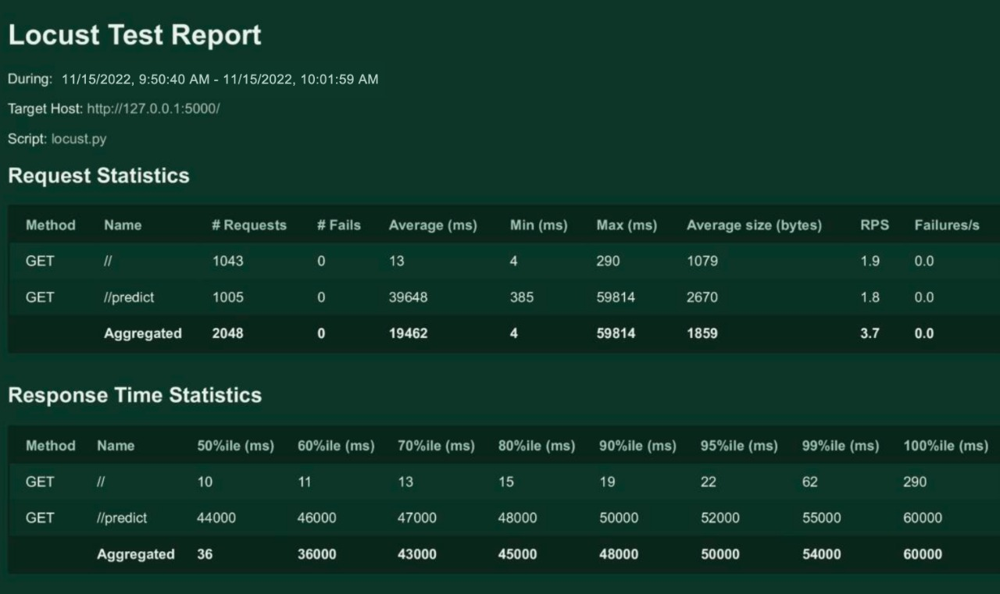

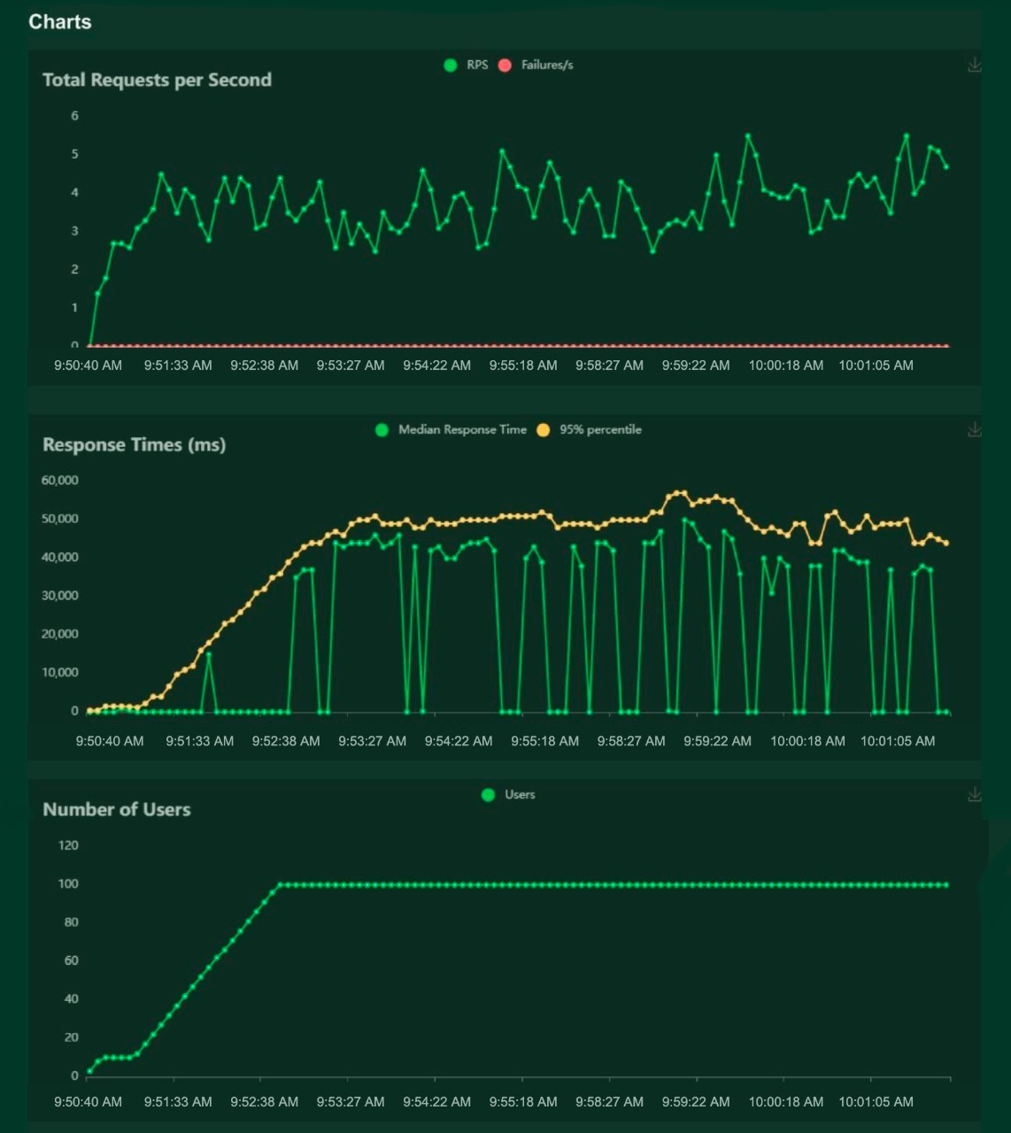

# CHAPTER 10

## ADVANTAGES & DISADVANTAGES

### ADVANTAGES

* + - Reduces manual work
    - More accurate than average human
    - Capable of handling a lot of data
    - Can be used anywhere from any device
    - Neural Network is used to train and identify written digits for greater efficiency.
    - The accuracy rate is very high.
    - Speed of data entry
    - It is much easier to dictate the machine than to write
    - Easier data retrieval

### DISADVANTAGES

* + - Cannot handle complex data
    - All the data must be in digital format
    - Requires a high performance server for faster predictions
    - Prone to occasional errors
    - There is a wide range of handwriting – good and bad.
    - It is tricky for programmers to provide enough examples of how every character might look.
    - Customers must try with clear image and neat handwriting to get accuracy in digits.
    - Unclear image will not give accurate results.

**CHAPTER 11**

## CONCLUSION

Convolutional Neural Network (CNN) adds its significant improvement to the Manuscript Document Recognition System. This paper tells us the effectiveness of CNN-based classification of data and pre-processing methods. Our model clearly sees handwriting and achieves outgoing predictions of up to 82.16% and accurate predictions of up to 69.16%. However the model can be continuously developed using multiple training samples. This will help the model to learn as well as the generalize better. There are many images in the training set that are completely invisible to the human eye.

This project demonstrated a web application that uses machine learning to recognize handwritten numbers. Flask, HTML, CSS, JavaScript, and a few other technologies were used to create this project. The model predicts the handwritten digit using a CNN network. During testing, the model achieved a 99.61% recognition rate. The proposed project is scalable and can easily handle a huge number of users. Since it is a web application, it is compatible with any device that can run a browser. This project is extremely useful in real-world scenarios such as recognizing number plates of vehicles, processing bank cheque amounts, numeric entries in forms ﬁlled up by hand (tax forms) and so on.

Through extensive evaluation using a MNIST dataset, the present work suggests the role of various hyper-parameters. Fine tuning of hyper-parameters is essential in improving the performance of CNN architecture. We achieved a recognition rate of 99.89% with the Adam optimizer for the MNIST database, which is better than all previously reported results. The effect of increasing the number of convolutional layers in CNN architecture on the performance of handwritten digit recognition is clearly presented through the experiments.

# CHAPTER 12

## FUTURE SCOPE

This project can be enhanced with a great field of machine learning and artificial intelligence. The world can think of a software which can recognize the text from a picture and can show it to the others, for example a shop name detector. Or this project can be extended to a greater concept of all the character sets in the world. This project has not gone for the total English alphabet because there will be more and many more training sets and testing values that the neural network model will not be enough to detect. Think of a AI modeled car sensor going with a direction modeling in the roadside, user shall give only the destination.

All of these enhancement is an application of the texture analysis where advanced image processing, Neural network model for training and advanced AI concepts will come. These applications can be modeled further .As this project is fully done by free and available resources and packages this can be also a limitation of the project. The fund is very important because all machine learning libraries and advanced packages are not available for free. Unless of those the most of the visualizing platforms like on which developers are doing some works like Watson Studio or Aws. These all are mainly paid platforms where a lot of ML projects are going on.

This project is far from complete and there is a lot of room for improvement.

Some of the improvements that can be made to this project are as follows:

* + - Add support to detect from digits multiple images and save the results
    - Add support to detect multiple digits
    - Improve model to detect digits from complex images
    - Add support to different languages to help users from all over the world

This project has endless potential and can always be enhanced to become better. Implementing this concept in the real world will beneﬁt several industries and reduce the workload on many workers, enhancing overall work efﬁciency.

## APPENDIX

### SOURCE CODE

**MODEL CREATION:**

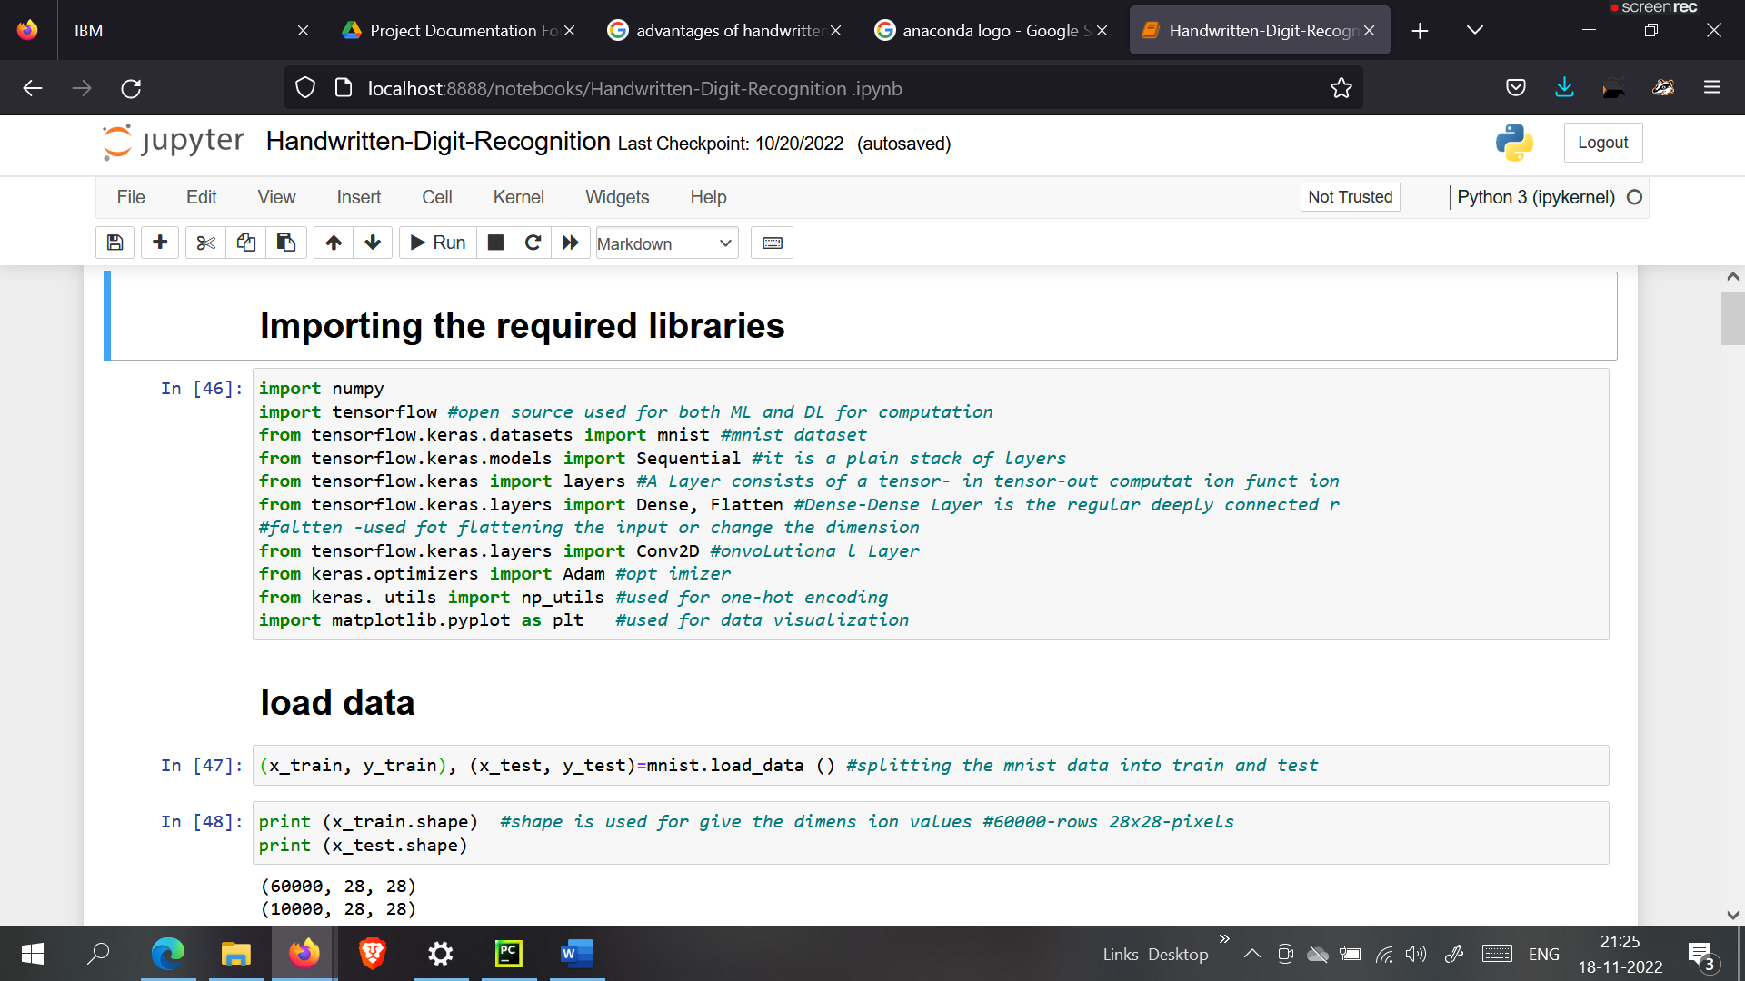

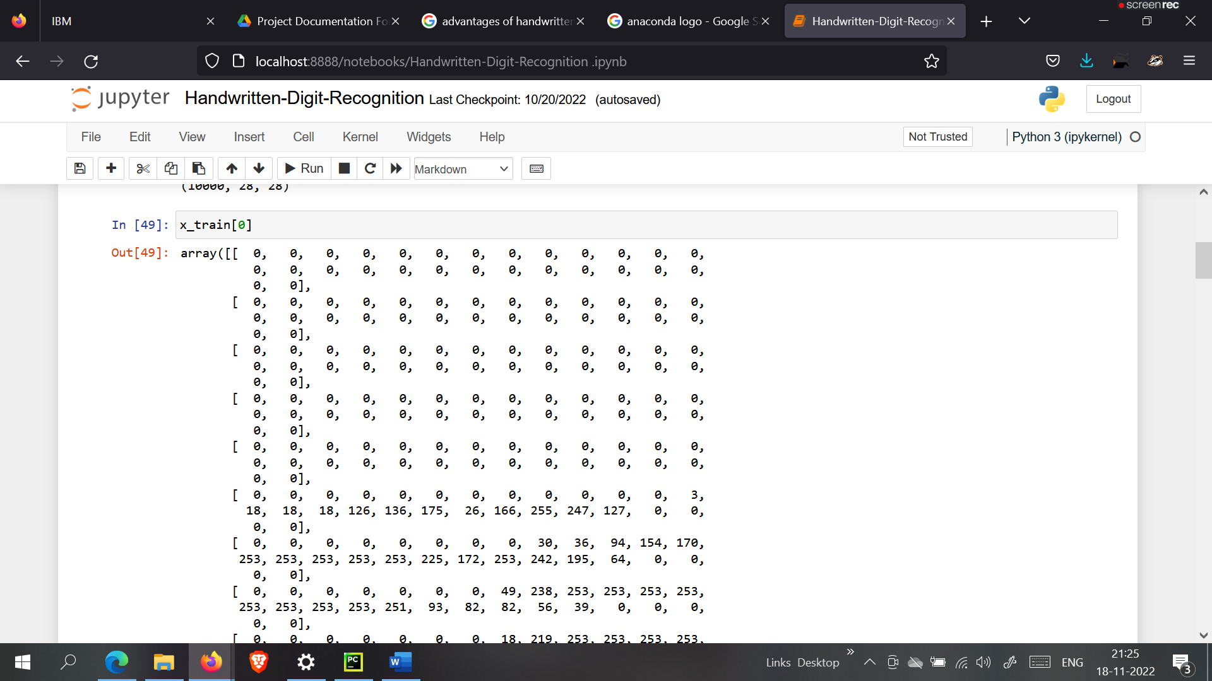

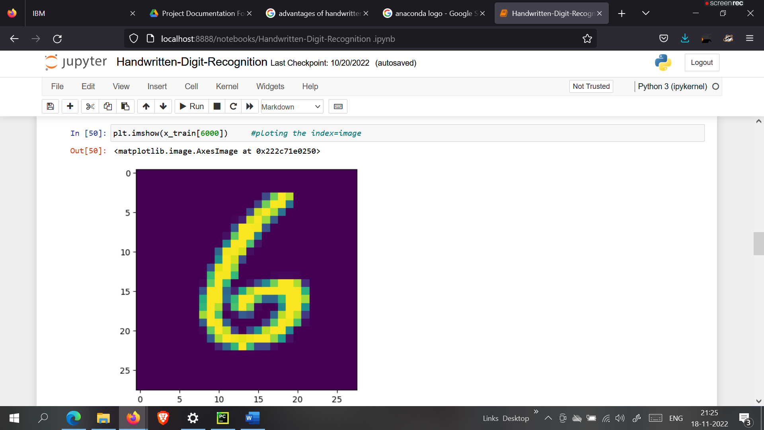

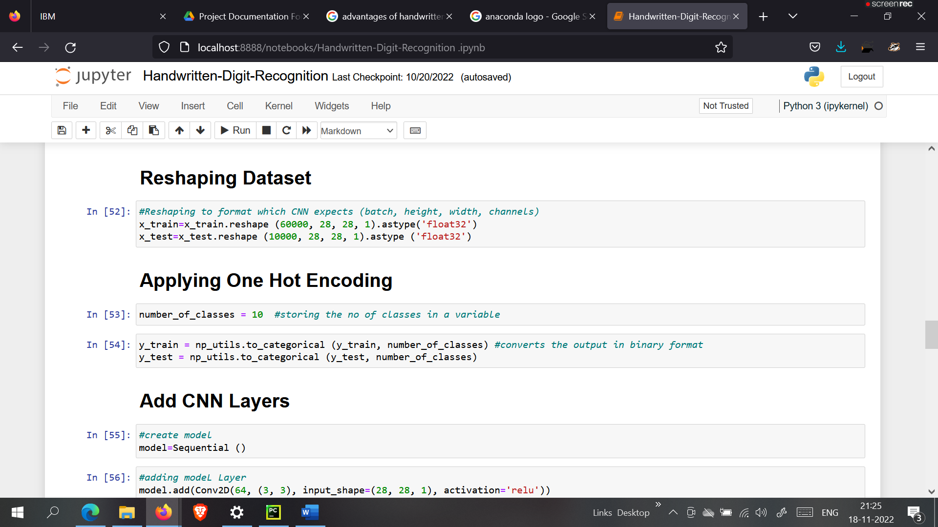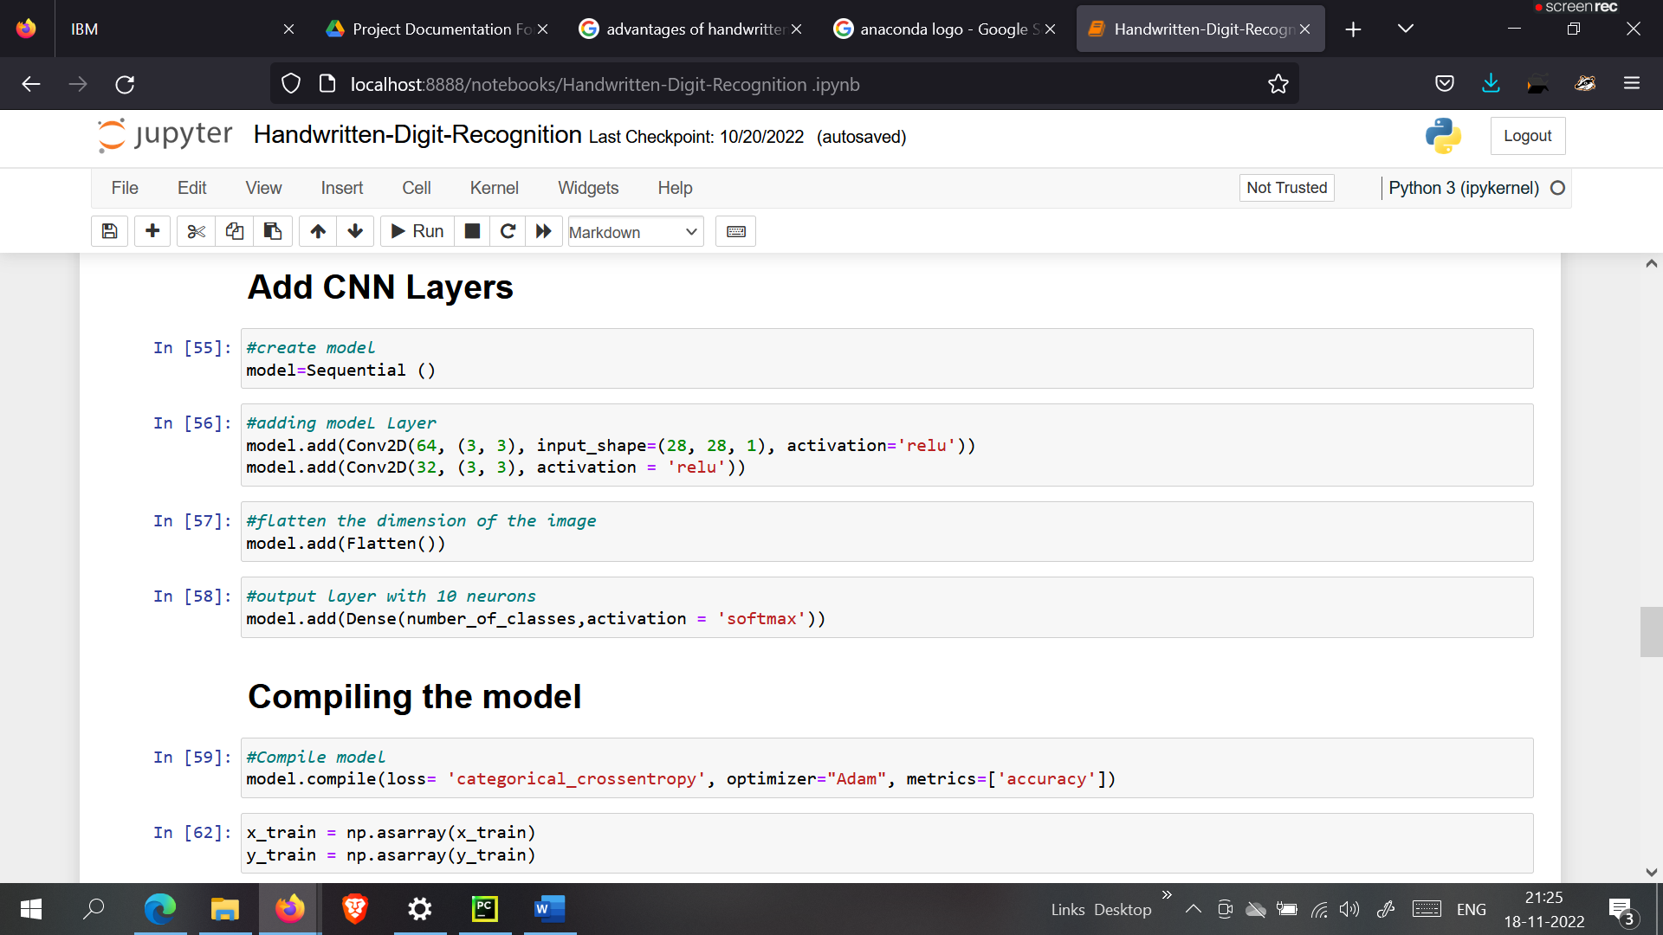

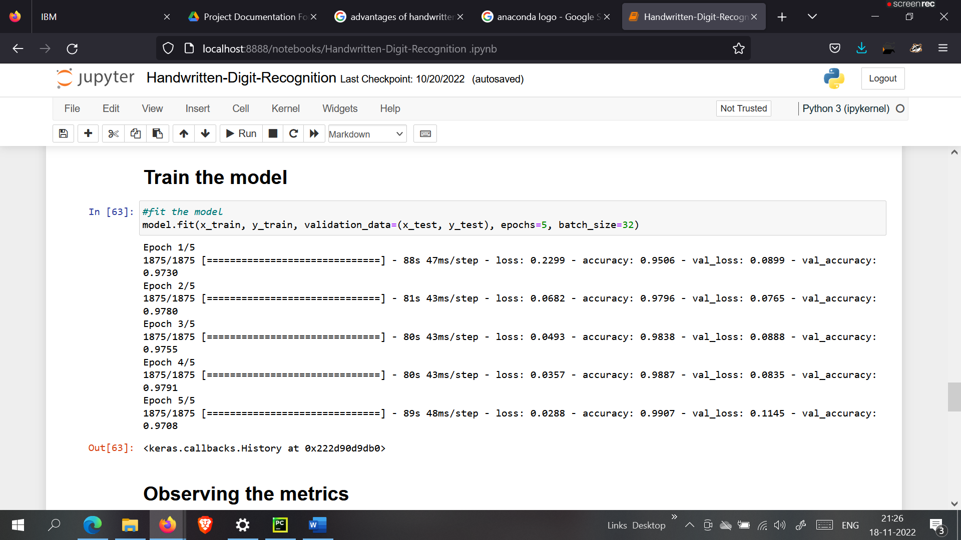

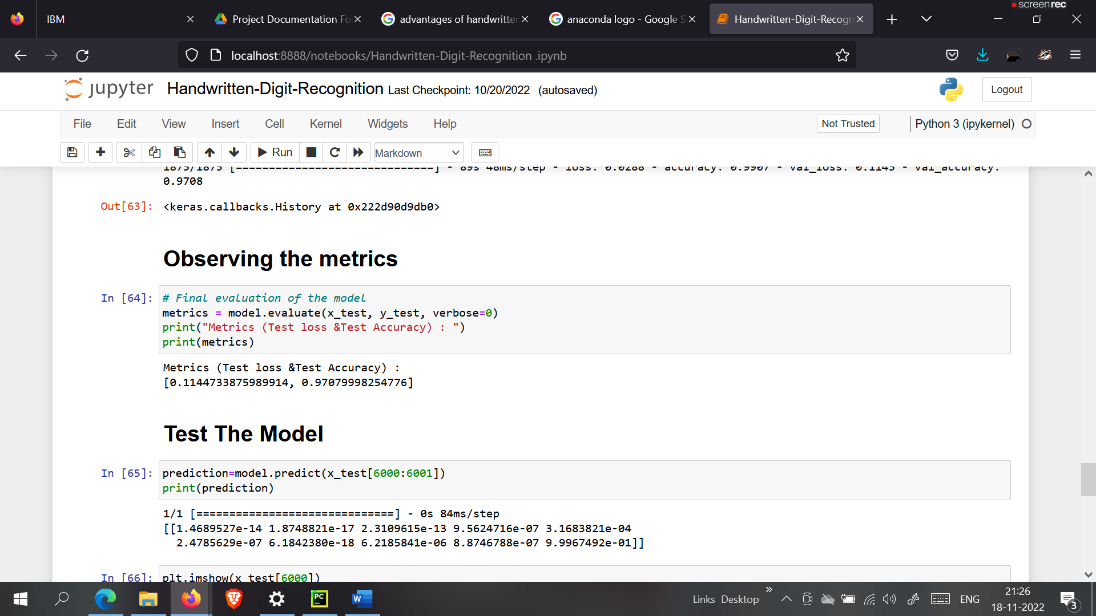

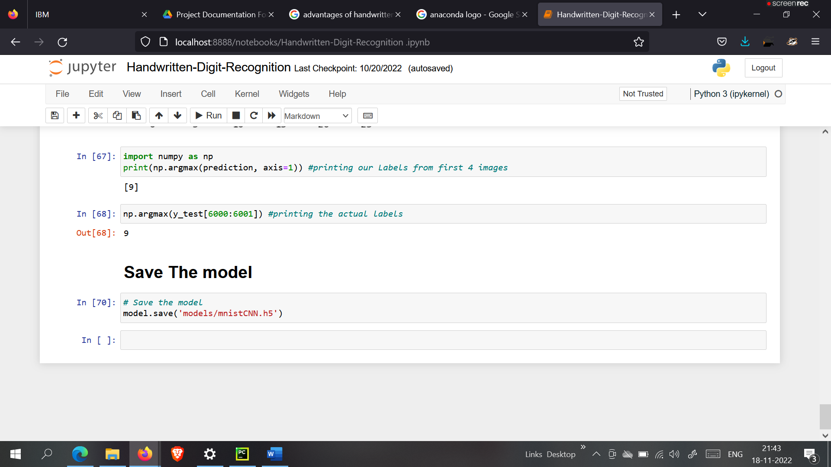

**CNNPREDICTION:**

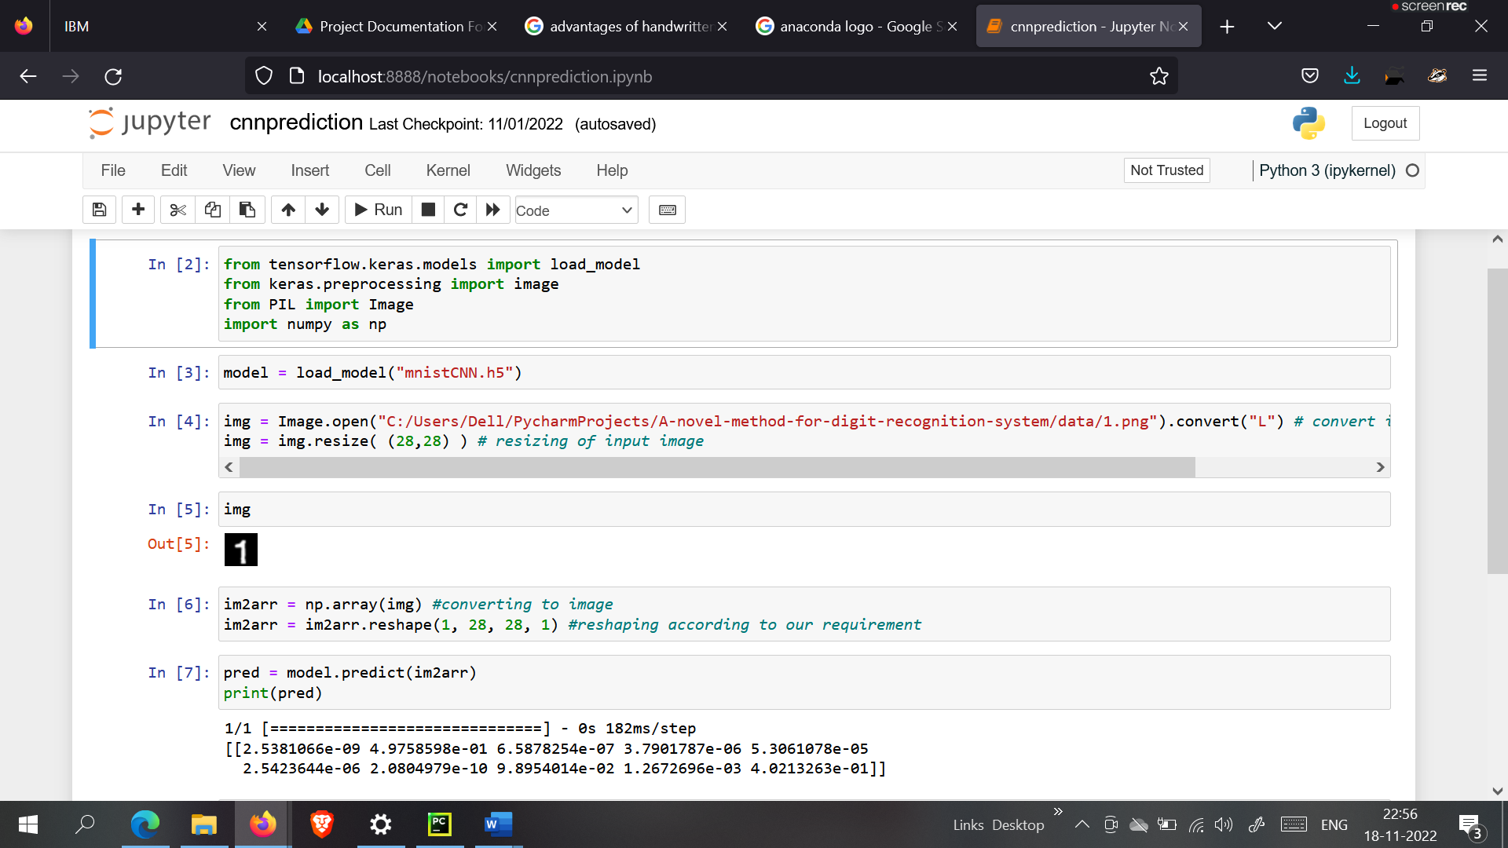

### TRAIN THE MODEL ON IBM:

### 

**HOME PAGE(HTML) – index.html**

<html>  
  
<head>  
 <title>Digit Recognition WebApp</title>  
  
 <meta name="viewport" content="width=device-width">

<! —Google Font -->  
 <link href="https://fonts.googleapis.com/css2?family=Prompt:wght@600&display=swap" rel="stylesheet">  
 <link href="https://fonts.googleapis.com/css2?family=Varela+Round&display=swap" rel="stylesheet">  
 <link href="https://fonts.googleapis.com/css2?family=Source+Code+Pro:wght@500&display=swap" rel="stylesheet">  
 <link href="https://fonts.googleapis.com/css?family=Calistoga|Josefin+Sans:400,700|Pacifico&display=swap" rel="stylesheet">

<! -- bootstrap -->  
 <link rel="stylesheet" href="https://stackpath.bootstrapcdn.com/bootstrap/4.3.1/css/bootstrap.min.css" integrity="sha384-ggOyR0iXCbMQv3Xipma34MD+dH/1fQ784/j6cY/iJTQUOhcWr7x9JvoRxT2MZw1T" crossorigin="anonymous">  
 <link rel="stylesheet" type= "text/css" href= "{{url_for ('static’, filename='css/style.css')}}">

<!—font awesome -->  
 <script src="https://kit.fontawesome.com/b3aed9cb07.js" crossorigin="anonymous"></script>  
  
 <script src="https://code.jquery.com/jquery-3.3.1.slim.min.js" integrity="sha384-q8i/X+965DzO0rT7abK41JStQIAqVgRVzpbzo5smXKp4YfRvH+8abtTE1Pi6jizo" crossorigin="anonymous"></script>  
 <script src="https://cdnjs.cloudflare.com/ajax/libs/popper.js/1.14.7/umd/popper.min.js" integrity="sha384-UO2eT0CpHqdSJQ6hJty5KVphtPhzWj9WO1clHTMGa3JDZwrnQq4sF86dIHNDz0W1" crossorigin="anonymous"></script>  
 <script src="https://stackpath.bootstrapcdn.com/bootstrap/4.3.1/js/bootstrap.min.js" integrity="sha384-JjSmVgyd0p3pXB1rRibZUAYoIIy6OrQ6VrjIEaFf/nJGzIxFDsf4x0xIM+B07jRM" crossorigin="anonymous"></script>  
 <script src="https://cdn.jsdelivr.net/npm/@tensorflow/tfjs@latest"></script>  
  
</head>  
  
<script>  
 function preview() {  
 frame.src=URL.createObjectURL(event.target.files[0]);  
}  
  
 $(document).ready(function() {  
 $('#clear_button').on('click', function() {  
 $('#image').val('');  
 $('#frame').attr('src',"");  
 });  
 });  
  
</script>

<body>  
  
 <h1 class="welcome">IBM PROJECT  
 <div id="team_id">TEAM ID: PNT2022TMID27424</div>  
 </h1>  
 <section id="title">  
 <h4 class="heading">Handwritten Digit Recognition Website</h4>  
 <br><br>  
 <p>  
 The website is designed to predict the handwritten digit.  
 </p>  
 <p>  
 Handwriting recognition is one of the compelling research works going on because every individual in this world  
 has their own style of writing. It is the capability of the computer to identify and understand  
 handwritten digits or characters automatically. Because of the progress in the field of science and technology,  
 everything is being digitalized to reduce human effort.</p>  
  
 <br>  
 <p> Hence, there comes a need for handwritten digit recognition in many real-time applications.  
 MNIST data set is widely used for this recognition process and it has 70000 handwritten digits.  
 We use Artificial neural networks to train these images and build a deep learning model.  
 Web application is created where the user can upload an image of a handwritten digit.  
 This image is analysed by the model and the detected result is returned on to UI</p>  
  
 </section>  
  
 <section id="content">  
  
 <div class="leftside">  
 <form action="/predict" method="POST" enctype="multipart/form-data">  
 <label>Select a image:</label>  
 <input id="image" type="file" name="image" accept="image/png, image/jpeg" onchange="preview()"><br><br>  
 <img id="frame" src="" width="100px" height="100px"/>  
 <div class="buttons_div">  
 <button type="submit" class="btn btn-dark" id="predict_button">Predict</button>  
 <button type="button" class="btn btn-dark" id="clear_button">&nbsp Clear &nbsp</button>  
 </div>  
 </form>  
 </div>  
 </section>  
  
</body>  
  
</html>

**HOME PAGE(CSS) – style.css**

#clear_button{  
 margin-left: 15px;  
 font-weight: bold;  
 color: blue;  
}  
  
#confidence{  
 font-family: 'Josefin Sans', sans-serif;  
 margin-top: 7.5%;  
}  
  
#content{  
 margin: 0 auto;  
 padding: 2% 15%;  
 padding-bottom: 0;  
}  
  
.welcome{  
 text-align: center;  
 position: relative;  
 color: honeydew;  
 background-color: greenyellow;  
 padding-top: 1%;  
 padding-bottom: 1%;  
 font-weight: bold;  
 font-family: 'Prompt', sans-serif;  
}  
  
#team_id{  
 text-align: right;  
 font-size: 25px;  
 padding-right: 3%;  
}  
  
#predict_button{  
 margin-right: 15px;  
 color: blue;  
 font-weight: bold;  
}  
  
#prediction_heading{  
 font-family: 'Josefin Sans', sans-serif;  
 margin-top: 7.5%;  
}  
  
#result{  
 font-size: 5rem;  
}  
  
#title{  
 padding: 1.5% 15%;  
 margin: 0 auto;  
 text-align: center;  
}  
  
.btn {  
 font-size: 15px;  
 padding: 10px;  
 webkit-appearance: none;  
 background: #eee;  
 border: 1px solid #888;  
 margin-top: 20px;  
 margin-bottom: 20px;  
}  
  
.buttons_div{  
 margin-bottom: 30px;  
 margin-right: 80px;  
}  
  
.heading{  
 font-family: 'Varela Round', sans-serif;  
 font-weight: 700;  
 font-size: 2rem;  
 display: inline;  
}  
  
.leftside{  
 text-align: center;  
 margin: 0 auto;  
 margin-top: 2%;  
 /* padding-left: 10%; */  
}  
  
#frame{  
 margin-right: 10%;  
}  
  
.predicted_answer{  
 text-align: center;  
 margin: 0 auto;  
 padding: 3% 5%;  
 padding-top: 0;  
 /* padding-left: 10%; */  
}  
  
p{  
 font-family: 'Source Code Pro', monospace, sans-serif;  
 margin-top: 1%;  
}  
  
@media (min-width: 720px) {  
 .leftside{  
 padding-left: 10%;  
 }  
}

**PREDICT PAGE (HTML) – predict.html**

<!DOCTYPE html>  
<html lang="en">  
<head>  
 <meta charset="UTF-8">  
 <title>Prediction</title>  
</head>  
  
<style>  
 body{  
 background-image: url('static/images/index6.jpg');  
 background-repeat: no-repeat;  
 background-size: cover;  
 }  
  
 #rectangle{  
 width:400px;  
 height:150px;  
 background-color: #5796a5;  
 border-radius: 25px;  
 position: absolute;  
 top:25%;  
 left:50%;  
 transform: translate(-50%,-50%);  
 }  
  
 #ans{  
 text-align: center;  
 font-size: 40px;  
 margin: 0 auto;  
 padding: 3% 5%;  
 padding-top: 15%;  
 color: white;  
 }  
  
</style>  
<body>  
 <div id="rectangle">  
 <h1 id="ans">Predicted Number : {{num}}</h1>  
 </div>  
</body>  
</html>

**FLASK APP - app.py**

import numpy as np  
import os  
from PIL import Image  
from flask import Flask, request, render_template  
from werkzeug.utils import secure_filename  
from keras.models import load_model  
  
UPLOAD_FOLDER = 'C:/Users/Dell/PycharmProjects/A-novel-method-for-digit-recognition-system/flask_app/uploads'  
  
  
app = Flask(__name__)  
app.config['UPLOAD_FOLDER'] = UPLOAD_FOLDER  
  
model = load_model("mnistCNN.h5")  
  
  
@app.route('/')  
def index():  
 return render_template('index.html')  
  
  
@app.route('/predict', methods=['GET', 'POST'])  
def upload():  
 if request.method == "POST":  
 f = request.files["image"]  
 filepath = secure_filename(f.filename)  
 f.save(os.path.join(app.config['UPLOAD_FOLDER'], filepath))  
  
 upload_img = os.path.join(UPLOAD_FOLDER, filepath)  
 img = Image.open(upload_img).convert("L") # convert image to monochrome  
 img = img.resize((28, 28)) # resizing of input image  
  
 im2arr = np.array(img) # converting to image  
 im2arr = im2arr.reshape(1, 28, 28, 1) # reshaping according to our requirement  
  
 pred = model.predict(im2arr)  
  
 num = np.argmax(pred, axis=1) # printing our Labels  
  
 return render_template('predict.html', num=str(num[0]))  
  
  
if __name__ == '__main__':  
 app.run(debug=True, threaded=False)

**GITHUB LINK:**

[**https://github.com/IBM-EPBL/IBM-Project-20414-1659718946**](https://github.com/IBM-EPBL/IBM-Project-20414-1659718946)